Freelancing Application MERN

**INTRODUCTION**

SB Works, an innovative freelance marketplace is a comprehensive digital workspace for independent professionals and project owners that connects project owners with skilled independent professionals. It offers an intuitive user-centric dashboard for project posting, bidding, and streamlined partnership and teamwork. With a dedicated platform management team team ensuring data integrity and safe transactions and smooth interactive dialogue system, SB Works, an innovative freelance marketplace aims to be the go-to platform for both project owners and independent professionals.

**Description**

Welcome to SB Works, an innovative freelance marketplace, a revolutionary comprehensive digital workspace for independent professionals and project owners that transforms the way project owners connect with skilled independent professionals. Our intuitive user-centric dashboard provides project owners with the opportunity to post diverse tasks and assignments, ranging from creative endeavours to technical tasks, while independent professionals can seamlessly bid on these tasks and assignments based on their expertise and capabilities.

At SB Works, an innovative freelance marketplace, we prioritize efficiency and transparency in the freelancing process. Clients can review freelancer profiles, assess past work, and select the perfect candidate for their project. Once a freelancer is chosen, the client can easily communicate and collaborate with them within the platform, streamlining the entire workflow.

Our dedicated platform management team team ensures the integrity and data integrity and safe transactions of every transaction. With stringent oversight, we guarantee the reliability and quality of the independent professionals on our platform. The platform management team's role is not only to maintain the platform's integrity but also to facilitate smooth interactive dialogue system between project owners and independent professionals, ensuring a positive and productive working relationship.

Freelancers on SB Works, an innovative freelance marketplace benefit from a straightforward project submission process. After completing the assigned project, independent professionals can submit their work directly through the platform, offering project owners a hassle-free experience. Clients have the opportunity to review the work and provide feedback, fostering a collaborative environment that values excellence.

Stay informed about the latest tasks and assignments and industry trends with real-time updates and notifications. SB Works, an innovative freelance marketplace aims to be the go-to platform for project owners seeking reliable independent professionals and independent professionals looking for exciting opportunities to showcase their skills.

Join SB Works, an innovative freelance marketplace today and experience a new era of freelancing where your tasks and assignments are efficiently managed, your skills are recognized, and partnership and teamworks flourish in a secure and dynamic environment.

**Scenario based case-study**

Sarah, a recent graduate with a degree in graphic design, is eager to showcase her skills and build a strong freelance portfolio. She stumbles upon SB Works, an innovative freelance marketplace while searching for online freelancing opportunities.

Finding the Perfect Project: Impressed by the user-friendly user-centric dashboard, Sarah browses through various project categories. She discovers a project posted by a local bakery, "Sugar Rush," seeking a logo redesign. The project description details the bakery's brand identity and target audience, giving Sarah a clear understanding of the client's needs.

Bidding with Confidence: Confident in her design skills, Sarah dives into the project details. SB Works, an innovative freelance marketplace allows her to review the bakery's previous marketing materials, further solidifying her design approach. She submits a compelling proposal highlighting her relevant experience and attaching a few samples from her portfolio stored securely within the platform.

Communication & Collaboration: "Sugar Rush" selects Sarah's proposal based on her impressive portfolio and competitive pricing. SB Works, an innovative freelance marketplace facilitates seamless interactive dialogue system between Sarah and the bakery, allowing them to discuss project specifics and refine the design direction through an integrated chat system.

Delivery & Feedback: Once finalized, Sarah submits her logo design through the SB Works, an innovative freelance marketplace platform. "Sugar Rush" can review the design, provide feedback, and request minor revisions if needed. SB Works, an innovative freelance marketplace fosters a collaborative environment where both parties can work towards achieving the desired outcome.

Building a Thriving Career: Following a successful project completion and a glowing review from "Sugar Rush," Sarah's profile on SB Works, an innovative freelance marketplace gains traction. The positive experience encourages her to actively seek new tasks and assignments on the platform. With a growing portfolio and strong client testimonials, Sarah is well on her way to establishing a thriving freelance career on SB Works, an innovative freelance marketplace.

**TECHNICAL ARCHITECTURE**

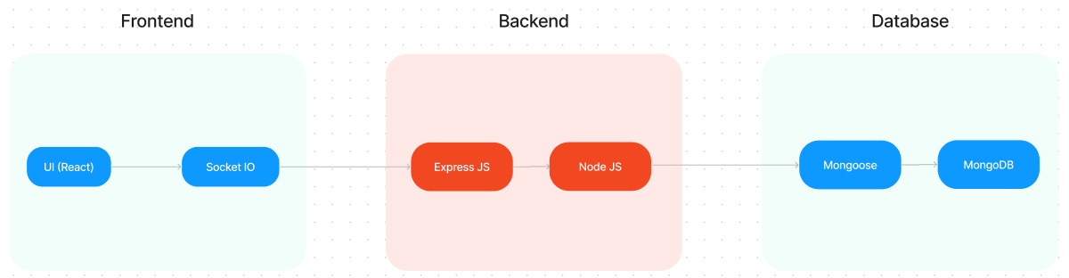

The technical architecture of SB Works, an innovative freelance marketplace follows a client-server model, where the frontend serves as the client and the backend acts as the server. The frontend encompasses the user user-centric dashboard, presentation, and integrates the Axios library to facilitate easy interactive dialogue system with the backend through RESTful APIs.

To enhance the user experience, the frontend leverages the Bootstrap and Material UI libraries, creating a real-time and visually appealing user-centric dashboard for users.

On the backend, we utilize the Express Js framework to manage server-side logic and interactive dialogue system. Express Js provides a robust foundation for handling requests and responses efficiently.

For data storage and retrieval, SB Works, an innovative freelance marketplace relies on MongoDB. MongoDB offers a scalable and efficient solution for storing various data, including user-contributed locations and images. This ensures quick and reliable access to the information needed to enrich the local tourism experience.

In conjunction, the frontend and backend components, complemented by Express Js, and MongoDB, together form a comprehensive technical architecture for SB Works, an innovative freelance marketplace. This architecture facilitates real-time interactive dialogue system, efficient data exchange, and seamless integration, ensuring a smooth and immersive experience for users contributing to and exploring their local surroundings.

**ER DIAGRAM**

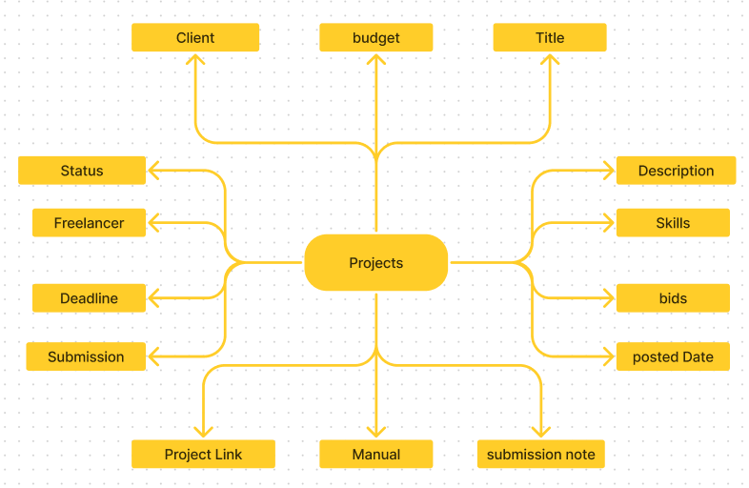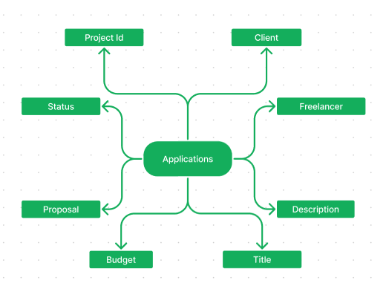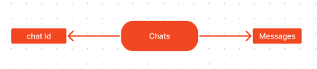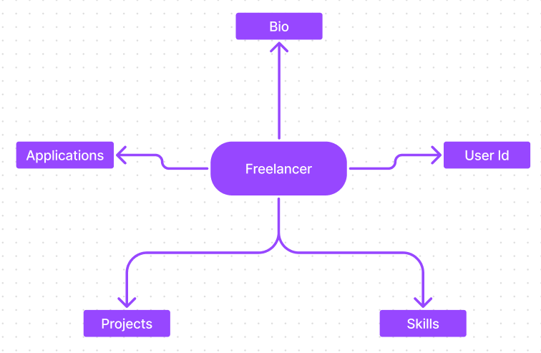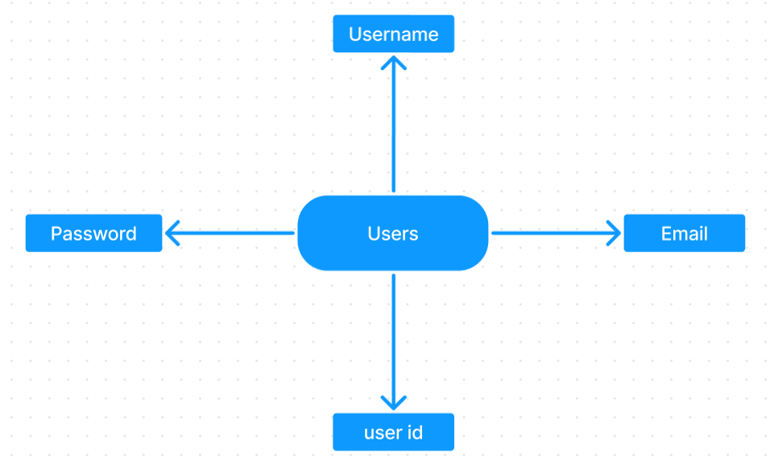

SB Works, an innovative freelance marketplace connects project owners with skilled independent professionals through a user-friendly platform. Clients can post tasks and assignments with details and browse freelancer profiles to find the perfect match. Freelancers can submit proposals, collaborate with project owners through secure chat, and securely submit work for review and payment. An platform management team team ensures quality and interactive dialogue system, making SB Works, an innovative freelance marketplace a go-to platform for both project owners and independent professionals.

**PROJECT STRUCTURE**

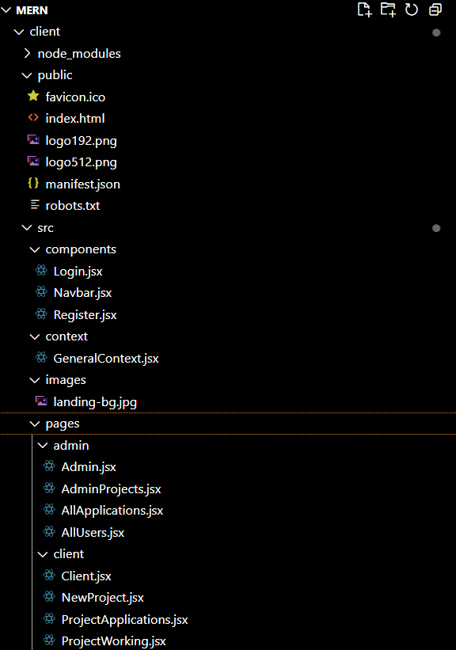

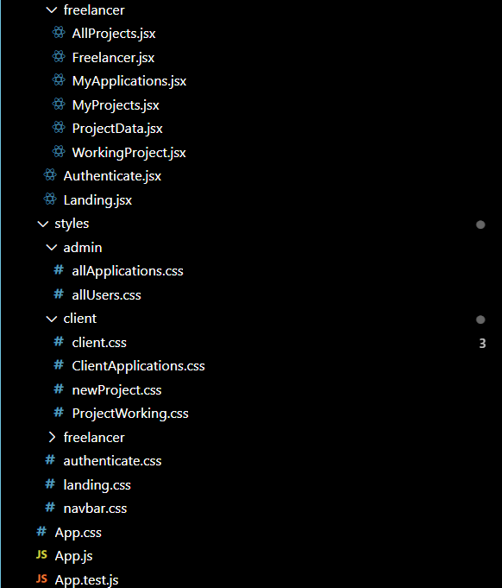

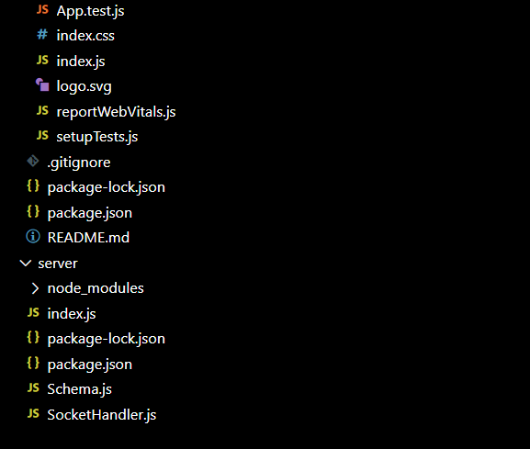

SB Works, an innovative freelance marketplace leverages React.js for the user user-centric dashboard. The client-side code likely consists of reusable components for profiles, tasks and assignments, and chat, assembled into pages like project browsing or freelancer profiles. Shared data like user info or search filters might be managed with React Context. On the server side, Node.js handles API requests for user management, project actions, and interactive dialogue system. Mongoose models ensure structured interaction with the MongoDB database. This breakdown provides a foundational understanding of SB Works, an innovative freelance marketplace' architecture.

**PRE-REQUISTIC:**

Here are the key prerequisites for developing a full-stack application using Express Js, MongoDB, React.js:

**✔Node.js and npm:** Node.js is a powerful JavaScript runtime environment that allows you to run JavaScript code on the server-side. It provides a scalable and efficient platform for building network applications. Install Node.js and npm on your development machine, as they are required to run JavaScript on the server-side

**✔Express.js:**Express.js is a fast and minimalist web application framework for Node.js. It simplifies the process of creating robust APIs and web applications, offering features like routing, middleware support, and modular architecture. Install Express.js, a web application framework for Node.js, which handles server-side routing, middleware, and API development.

**✔MongoDB:** MongoDB is a flexible and scalable NoSQL database that stores data in a JSON-like format. It provides high performance, horizontal scalability, and seamless integration with Node.js, making it ideal for handling large amounts of structured and unstructured data. Set up a MongoDB database to store your application's data.

**✔React.js:** React.js is a popular JavaScript library for building user user-centric dashboards. It enables developers to create interactive and reusable UI components, making it easier to build dynamic and responsive web applications. Install React.js, a JavaScript library for building user user-centric dashboards.

**✔HTML, CSS, and JavaScript:**Basic knowledge of HTML for creating the structure of your app, CSS for styling, and JavaScript for client-side interactivity is essential.

**✔Database Connectivity:** Use a MongoDB driver or an Object-Document Mapping (ODM) library like Mongoose to connect your Express Js server with the MongoDB database and perform CRUD (Create, Read, Update, Delete) operations

**✔Front-end Framework:** Utilize React Js to build the user-facing part of the application, including entering booking room, status of the booking, and user user-centric dashboards for the platform management team dashboard. For making better UI we have also used some libraries like material UI and bootstrap.

**✔Version Control:** Use Git for version control, enabling partnership and teamwork and tracking changes throughout the development process. Platforms like GitHub or Bitbucket can host your repository.

**✔Development Environment:** Choose a code editor or Integrated Development Environment (IDE) that suits your preferences, such as Visual Studio Code, Sublime Text, or WebStorm.

•Install the required dependencies by running the following commands:

cd client

npm install

../cd server

npm install

**Start the Development Server:**

• To start the development server, execute the following command:

npm start

• The SB Works, an innovative freelance marketplace app will be accessible at

You have successfully installed and set up the SB Works, an innovative freelance marketplace application on your local machine. You can now proceed with further customization, development, and testing as needed.

**Application flow:**

**Freelancer Responsibilities:**

• Project Submission: Freelancers are responsible for submitting completed and high-quality work for the assigned tasks and assignments through the platform.

• Compliance: Ensure that the submitted work adheres to client requirements, industry standards, and any specific guidelines outlined by the platform.

• Effective Communication: Actively engage in interactive dialogue system with project owners, promptly responding to messages, asking clarifying questions, and providing updates on the project progress.

• Time Management: Manage time effectively to meet project deadlines and deliver work in a timely manner.

• Professionalism: Conduct oneself professionally by maintaining a respectful and cooperative attitude with project owners and fellow independent professionals.

• Quality Assurance: Deliver work that is accurate, well-executed, and free from errors to maintain client satisfaction.

**Client Responsibilities:**

• Clear Project Description: Provide a detailed and comprehensive project description, including deliverables, desired outcomes, and any specific requirements.

• Timely Communication: Respond promptly to freelancer inquiries, providing necessary information and feedback in a timely manner.

• Payment Obligations: Fulfill the agreed-upon payment terms promptly and fairly upon satisfactory completion of the project.

• Feedback and Evaluation: Provide constructive feedback and evaluate the freelancer's performance, helping them improve and providing valuable insights.

**Admin Responsibilities:**

Data Oversight: As aplatform management team, one of your key responsibilities is to monitor and ensure the integrity and data integrity and safe transactions of all data on the platform

Policy Enforcement: Admins play a crucial role in enforcing platform policies, guidelines, and ethical standards.

Conflict Resolution: In the event of disputes or issues within the community, it is the platform management team's responsibility to address them promptly and impartially

User Support and Communication: Admins should provide support and guidance to users on the platform

Platform Maintenance and Improvement: Admins are responsible for the overall maintenance and improvement of the research platform.

**Project Flow:**

**Milestone 1: Project setup and configuration.**

Folder setup:

Now, firstly create the folders for frontend and backend to write the respective code and install the essential libraries.

Client folders.

Server folders

Installation of required tools:

1. Open the frontend folder to install necessary tools

For frontend, we use:

React

Bootstrap

Material UI

Axios

react-bootstrap

2. Open the backend folder to install necessary tools

For backend, we use:

Express Js

Node JS

MongoDB

Mongoose

Cors

Bcrypt

After the installation of all the libraries, the package.json files for the frontend looks like the one mentioned below.

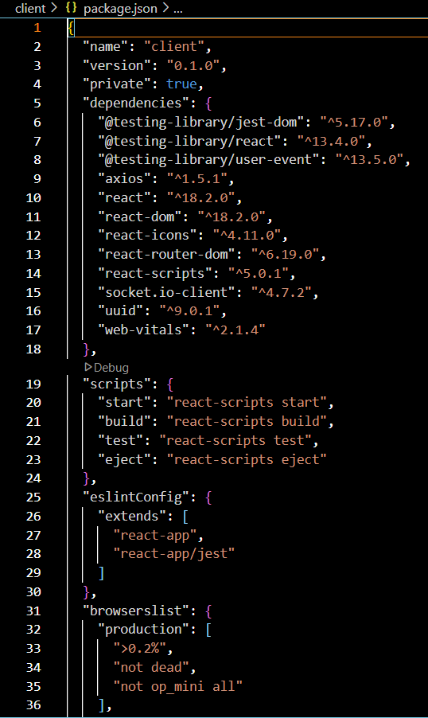

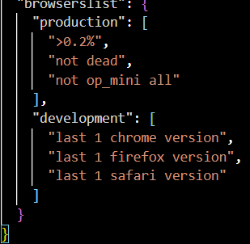

After the installation of all the libraries, the package.json files for the backend looks like the one mentioned below.

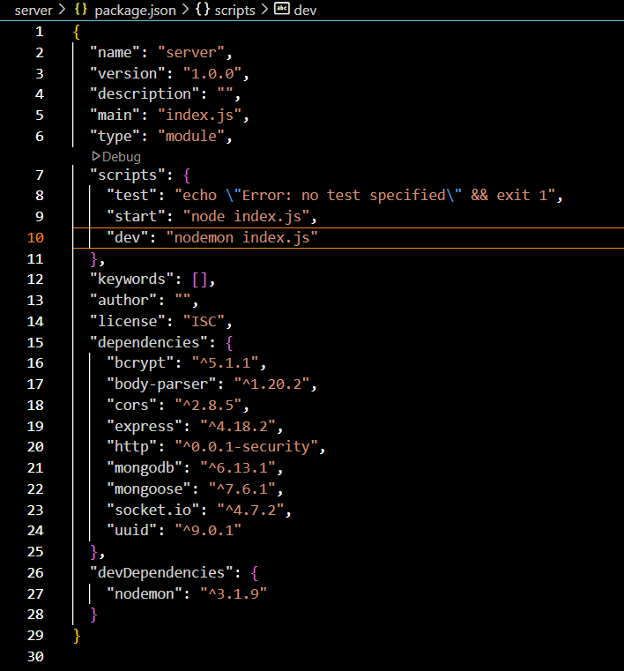

**Milestone 2: Backend Development**

**1. Project Setup:** Create a project directory and initialize it using npm init. Install required dependencies like Express.js, Mongoose, body-parser, and cors.

**2. Database Configuration:** Set up a MongoDB database (locally or using a cloud service like MongoDB Atlas).

Create collections for:

Users (storing user information, account type)

Projects (project details, budget, skills required)

Applications (freelancer proposals, rate, portfolio link)

Chat (interactive dialogue system history for each project)

Freelancer (extended user details with skills, experience, ratings)

**3. Express.js Server:** Create an Express.js server to handle HTTP requests and API endpoints. Configure body-parser to parse request bodies and cors for cross-origin requests.

**4. API Routes:** Define separate route files for user management, project listing, application handling, chat functionality, and freelancer profiles.

Implement route handlers using Express.js to interact with the database:

User routes: registration, login, profile management.

Project routes: project creation, listing, details retrieval.

Application routes: submit proposals, view applications.

Chat routes: send and receive messages within tasks and assignments.

Freelancer routes: view and update profiles, showcase skills.

**5. Data Models:** Define Mongoose schemas for each data entity:

User schema

Project schema

Application schema

Chat schema

Freelancer schema (extends User schema with skills, experience)

Create Mongoose models to interact with the MongoDB database.

Implement CRUD operations for each model to manage data.

**6. User Authentication:** Implement user authentication using JWT or session-based methods.Create routes and middleware for user registration, login, and logout.Use authentication middleware to protect routes requiring user authorization (e.g., applying for tasks and assignments).

**7. Project Management:** Allow project owners to post tasks and assignments with details and budget.Enable independent professionals to browse tasks and assignments, search by skills, and submit proposals.Implement a system for project owners to review applications and choose independent professionals.

**8. Secure Communication & Collaboration:** Integrate a secure chat system within tasks and assignments for interactive dialogue system between project owners and independent professionals.Allow file attachments and feedback exchange to facilitate partnership and teamwork.

**9. Admin Panel:** Implement a platform management team panel with functionalities like:

Managing users

Monitoring project updates and applications

Accessing transaction history

**Milestone 3: Database development**

Set up a MongoDB database either locally or using a cloud-based MongoDB service like MongoDB Atlas.

Create a database and define the necessary collections for users, freelancer, tasks and assignments, chats, and applications.

Connect the database to the server with the code provided below.

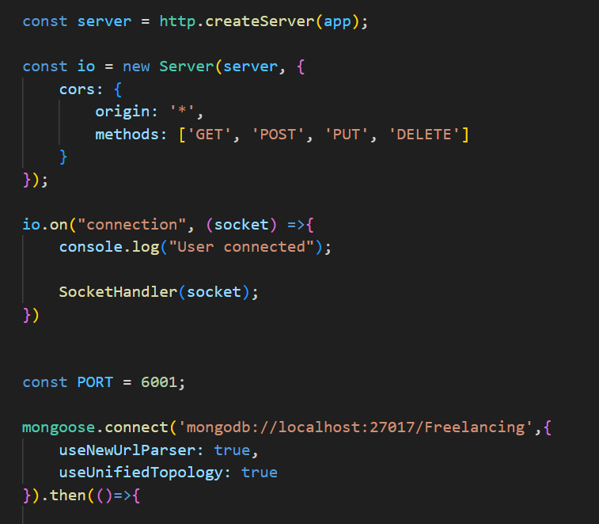

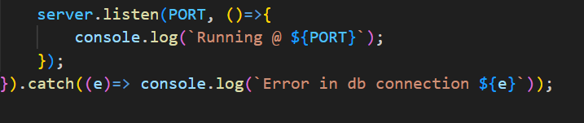

The Schemas for the database are given below.

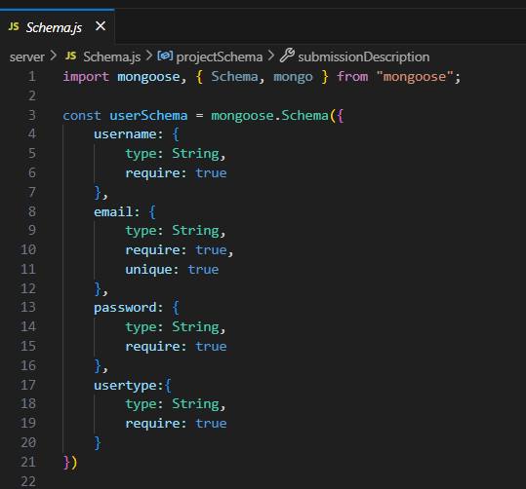

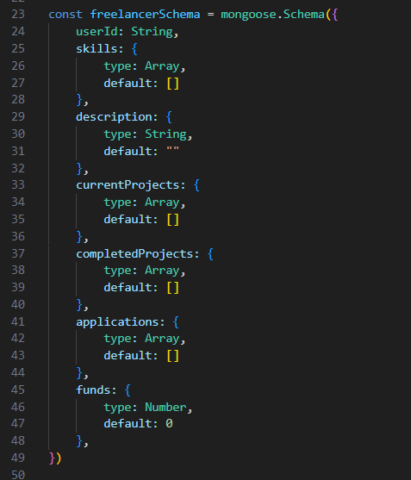

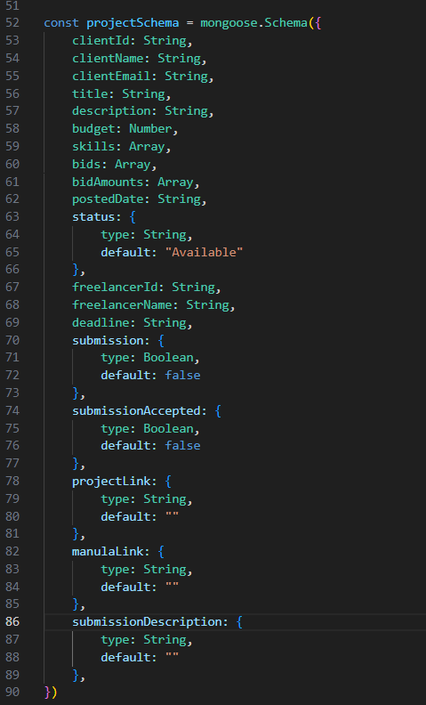

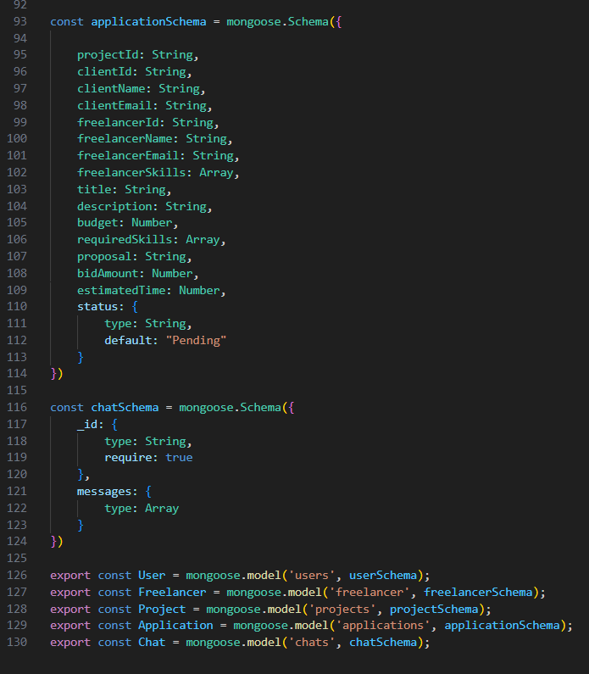

**Milestone 4: Frontend development**

**1. Setting the Stage:** The SB Works, an innovative freelance marketplace frontend thrives on React.js. To get started, we'll:

Create the initial React application structure.

Install essential libraries for enhanced functionality.

Organize project files for a smooth development experience.

This solid foundation ensures an efficient workflow as we bring the SB Works, an innovative freelance marketplace user-centric dashboard to life.

**2. Crafting the User Experience:** Next, we'll focus on the user user-centric dashboard (UI). This involves:

Designing reusable UI components like buttons, forms, and project cards.

Defining the layout and styling for a visually appealing and consistent user-centric dashboard.

Implementing navigation elements for intuitive movement between features.

These steps will create a user-friendly experience for both independent professionals and project owners.

**3. Bridging the Gap:** The final stage connects the visual user-centric dashboard with the backend data. We'll:

Integrate the frontend with SB Works, an innovative freelance marketplace API endpoints.

Implement data binding to ensure dynamic updates between user interactions and the displayed information.

This completes the frontend development, bringing the SB Works, an innovative freelance marketplace platform to life for users.

**Milestone 5: Project Implementation**

On completing the development part, we then run the application one last time to verify all the functionalities and look for any bugs in it. The user user-centric dashboard of the application looks a bit like the images provided below.

**Landing page:**

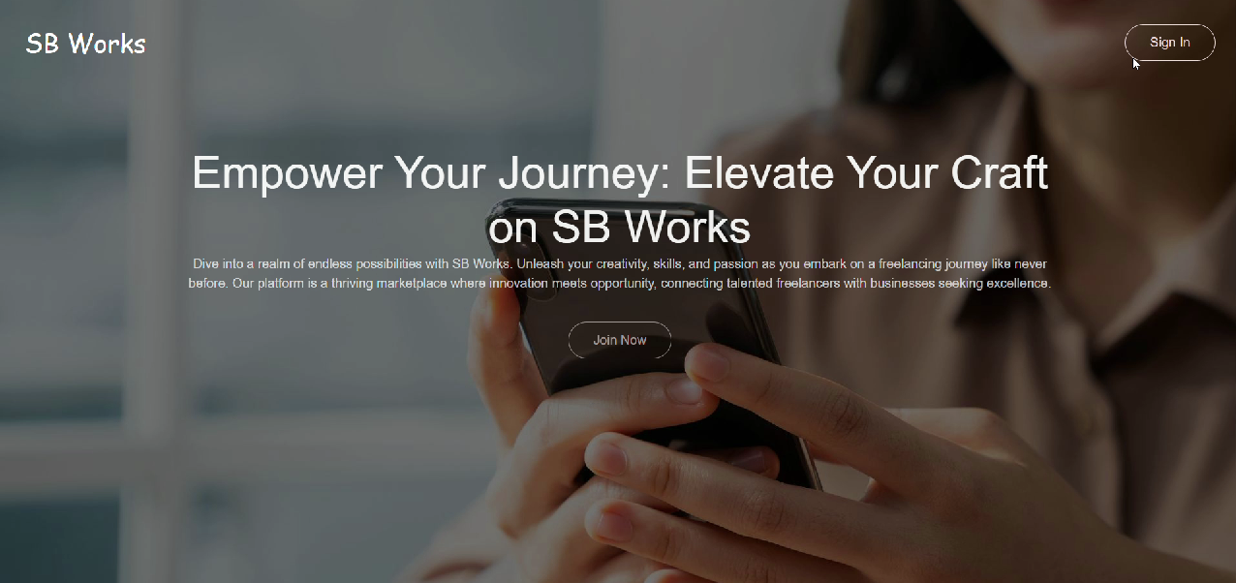

**Authentication:**

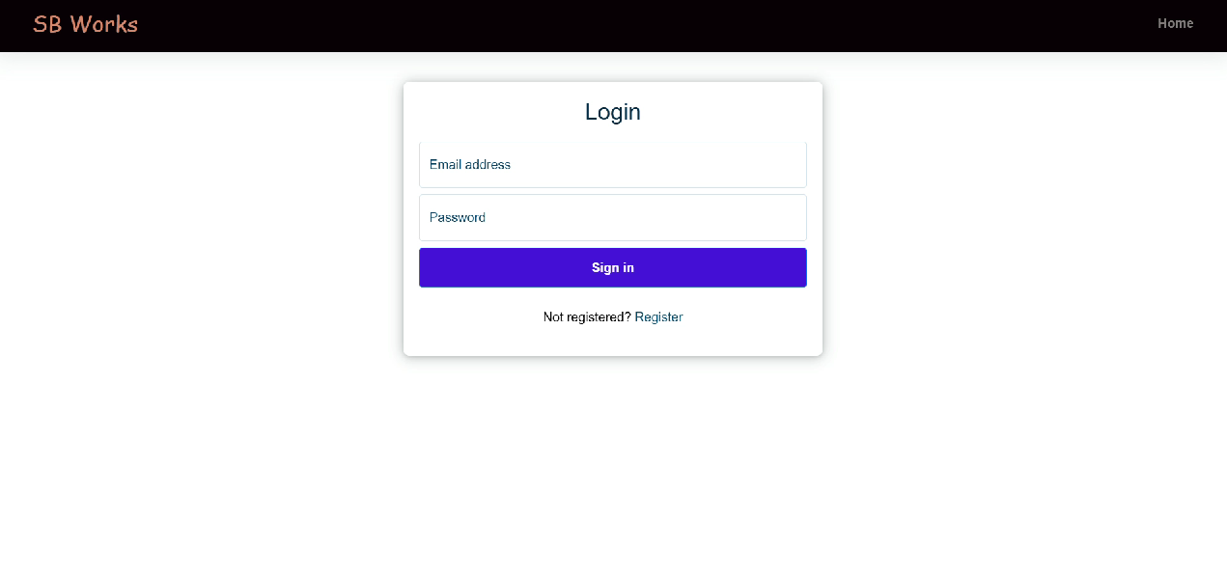

**Freelancer dashboard:**

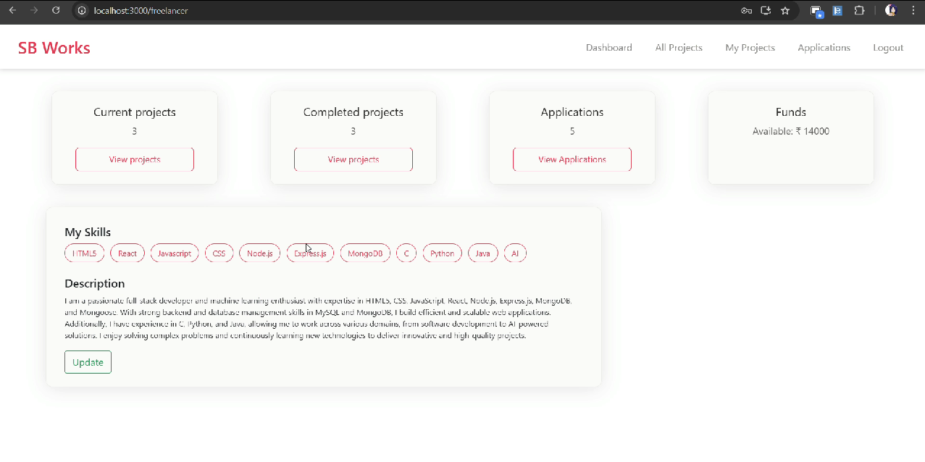

**Admin dashboard:**

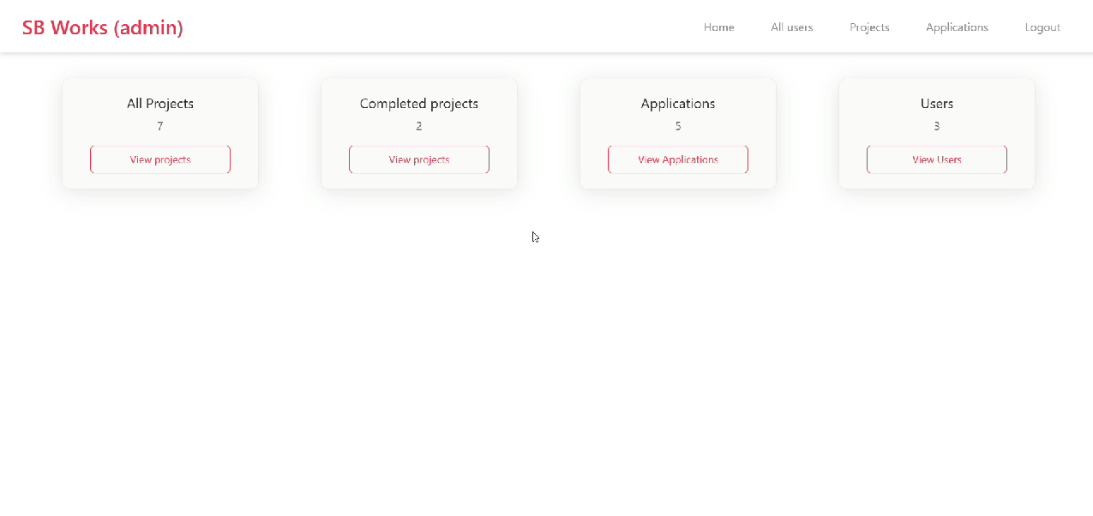

**All Projects:**

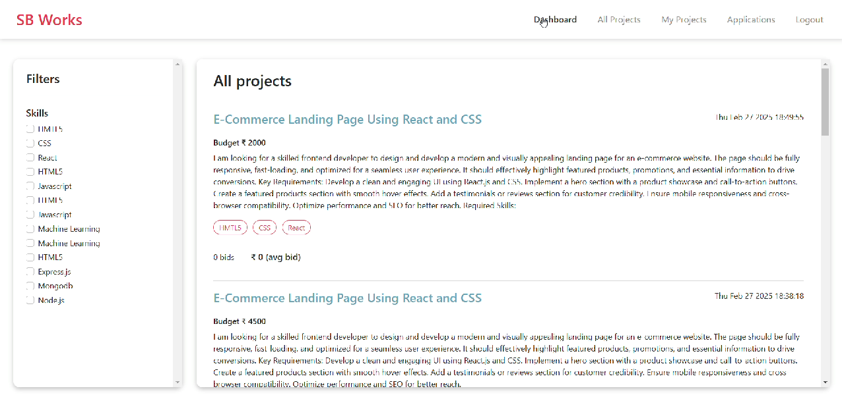

**Freelance Projects:**

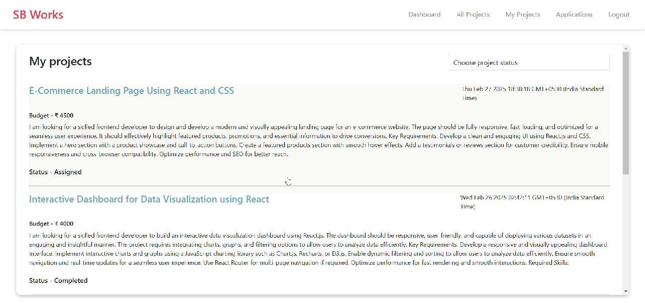

**Applications:**

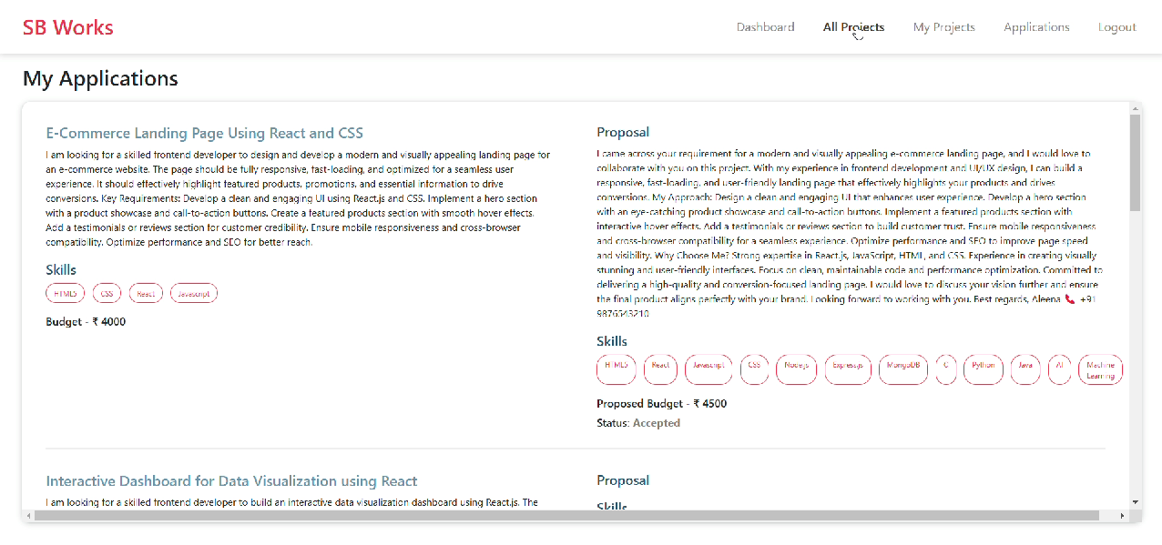

**Project page:**

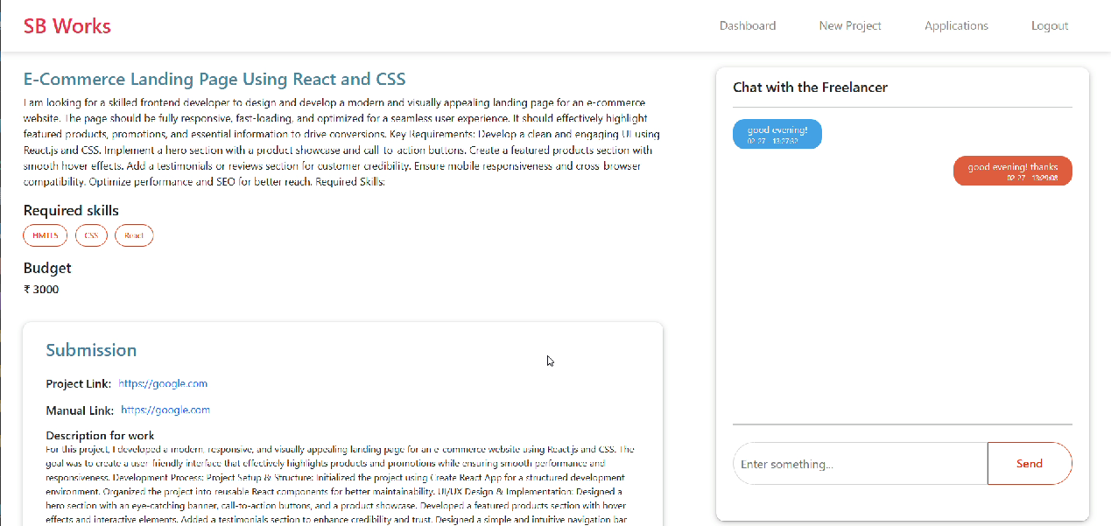

**New project:**

